**INFS 414**

**WEEK 3- ASSIGNMENT 3**

**QUESTION 2:**

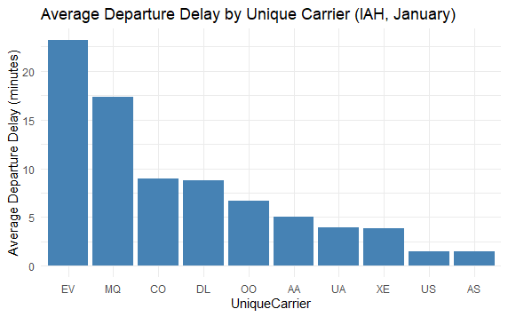

**QUESTION 2 (PART 1):**

Which carrier has the longest average departure delay?

**ANSWER:**

Carrier EV (ExpressJet) has the longest average departure delay, clocking in at 23.2 minutes.

**QUESTION 2 (PART 2):**

Which carrier has the shortest average departure delay?

**ANSWER:**

Carrier AS (Alaska Airlines) boasts the shortest average departure delay at just 1.45 minutes.

**QUESTION 2 (PART 3):**

Are there any noticeable trends in delays across carriers?

**ANSWER:**

There is a notable difference in average departure delays among carriers, with times ranging from 1.45 to 23.2 minutes. Regional carriers like EV (ExpressJet) and MQ (Envoy Air) tend to have longer delays compared to major airlines such as AS (Alaska Airlines) and US (US Airways), which report shorter delays. Larger, well-established carriers like AA (American Airlines) and UA (United Airlines) typically fall in the middle range for average delays.

These patterns may indicate that regional carriers encounter operational difficulties or employ different scheduling methods that lead to longer delays compared to their larger counterparts.